Sound in Air
2017-02-08
Cory Wolfe
Lab Partners: Ryan Goulden and Marshall Loper

For this experiment sounds at varying frequencies were played into a tube of varying length in order to find the resonant lengths, as visible on a graph. The hypothesis of this experiment is that the longitudinal sound waves may be relatable to the standing waves the group had previously experimented with.
This experiment required a speaker, sound sensor, analog to digital converter, function generator, DataStudio and a resonance tube apparatus. The equipment was set up in a way to allow for sound refelecting from the tube to be sensed. A diagram of the apparatus is shown in Figure 1. Useful equations include:

- γ (1.4) is the correction constant for air, R (8.314) is the gas constant, T is the temperature and M (28.7×10−3 kg mol) is the average molecular weight of air.
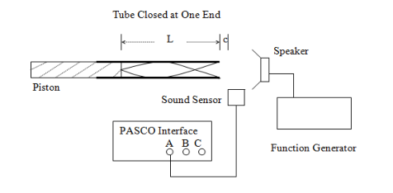
Figure 1: Diagram of Lab Setup
The procedure for this experiment involved setting up the apparatus as shown in Figure 1. Then the data was then recorded in DataStudio for 1.5, 2.5 and 3.5 kHz. The points the group was looking for were the minimums.
After this was completed the experiment was repeated with an additional thirty gram mass causing tension on the spring. The data collected in these experiments is available in Figure 2.

L = 1 m | 1 Freq(Hz) | 2 Freq(Hz) | 3Freq(Hz) | 4 Freq(Hz) | Velocity(m/s)
30 grams | 15 | 35 | 55 | 76 | 1.27
60 grams | 22.5 | 52.5 | 82.5 | 112.5 | 1.808
Figure 2: Table of Data

For this lab the group found that the increase in frequency followed a linear relationship, while not being simply multiplicable. When touching the node the string continued to vibrate, whereas the anti-nodes stopped the vibration, due to the fact that touching the string at the node would cause the vibration to stop. When the additional mass was added it caused some changes in the system. The velocity of the wave with additional mass increased, which makes sense because additional energy would be required. The thumper motor was counted as a node for this experiment while it may not truly be, because it creates movement , and thus does not stand still as a true node would.

